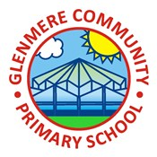
Year 6 Art & Design Knowledge Organiser Autumn
Drawing: Make My Voice Heard
Knowledge
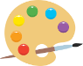 | Mark Making  - Mark making is an expressive technique.  - Different effects are created when drawing on different surfaces.  - A ‘monochromatic’ artwork uses tints and shades of just one colour.
Symbolic Imagery
- Colours can be symbolic and have meanings that vary according to your culture or background, e.g. red for danger or for celebration
- Artists can use symbols in their artwork to convey meaning.
- Art can be a form of protest.
Chiaroscuro
- Artists use this tonal technique to create dramatic light and shade when drawing or painting.
- Charcoal can be used to create chiaroscuro effects.
Street Art
- Sometimes artists add extra meaning to what they create by working in places where they don’t have permission to work.
- Sometimes people make art to express their views and opinions, which can be political or topical.
- Artists use art to tell stories about things that are important to them; looking at artworks from the past can reveal thoughts and opinions from that time.
Powerful Imagery
- Art can represent abstract concepts, like memories and experiences.
- Everyone has a unique way of experiencing art. Art can be interpreted in different ways.

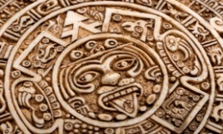

Key Vocabulary
Aesthetic | As an adjective, it describes something that is pleasing to look at
Commissioned | When someone is asked to create a piece of art
Interpretation | How the meaning of an image is understood
Mural | A painting made directly on a wall or other permanent structure
Symbolic | Conveying a message using symbols
Tone | How light or dark something is

