Music Knowledge Organiser -Year 6 – Happy
Song for the lesson;  Happy – Pharrell Williams  Key learning;  - Happy is written, produced AND performed by Pharrell Williams.  - It is a Pop song that has a soul music sound  - The tempo stays the same throughout but the dynamics get louder in the chorus when all the instruments play together | 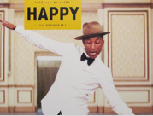
Song for the lesson;  Top of the World – The Carpenters  Key learning;  - This song is a pop song with a country groove  - The Carpenters were a brother and sister duo. They were one of the biggest-selling groups of the 1970s  - The dynamics in this song stay the same throughout. | 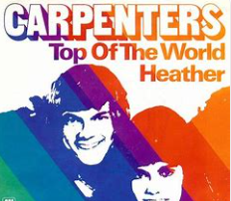
Song for the lesson;  Don’t Worry Be Happy – Bobby Mcferrin  Key learning:  - Don’t Worry, Be Happy is a cappella song. This means that only voices are used.  - In this song, he only uses his voice and he imitate all instruments vocally  - The music gets louder in the chorus when the backing vocals come in | 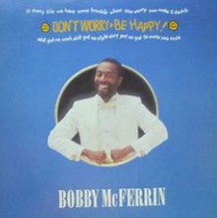
Song for the lesson;  Walking on Sunshine – Katrina and the Waves  Key learning:  - Walking on Sunshine is a soft rock song from 1983  - The tempo stays the same throughout, however, the dynamics is louder during the introduction and chorus | 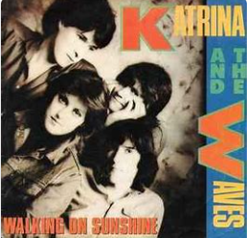
Song for the lesson;  When You’re Smiling- Frank Sinatra  Key learning:  - When You’re Smiling has been recorded by many different jazz singers. This version was recorded by Frank Sinatra and a big jazz band  - Frank Sinatra was one of the most popular and influential artists of the 20th Century | 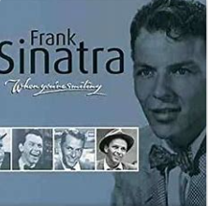
Song for the lesson;
Love Will Save the Day – Brendan Reilly
Key learning:
- This soul song is performed with a Latin groove and it a cover of Whitney Houstan
- Brendan Reilly is an American singer-songwriter of Jazz, Soul, Pop and Dance music
Dynamics | How loud or quiet the music is
Pop music | Shortened from popular music, this constantly changes over time
Structure | Every piece of music has a structure e.g. an introduction, verse, chorus and outro
A Capella | Without instruments – voices only
Key Words

