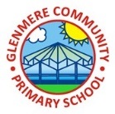
Music Knowledge Organiser -Year 6 – Music and Technology
Song for the lesson;  Do What You Want To  Key learning;  - The song is in C Major and the time signature is 4/4 which means there are four crotchet beats in a bar  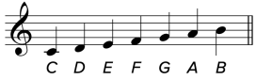  - The C major scale includes the note C, D, E, F, G, A, B  - ‘Do what you want to’ is soul music | 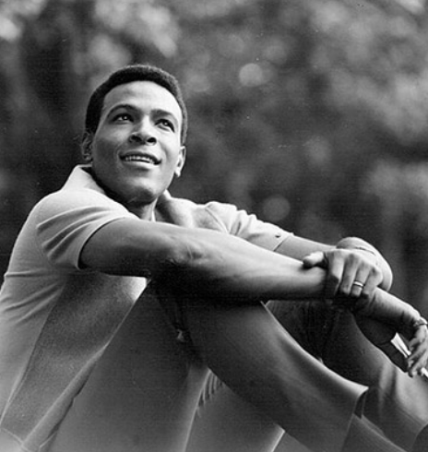
Song for the lesson;  Fanfare For the Common Man  Key learning;  - ‘Funfare for the common man’ is 20th Century Orchestral; it has complex timings, rhythms and harmonies  - The notes here are crotchets – they have the time value of one beat  - This has different time signatures throughout | 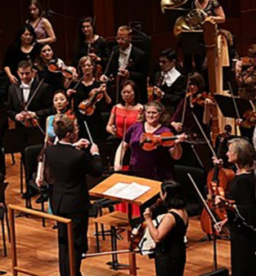
Song for the lesson;  It’s All About Love  Key learning:  - It’s All About Love is a pop song.  - The time signature again is four crotchet beats in a bar  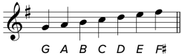  - The song is in G Major – of which there is one sharp- which means in a higher pitch | 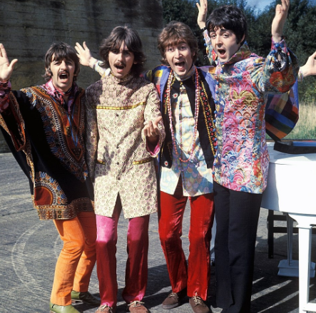
Song for the lesson;
Let’s Write A Song
Key learning:
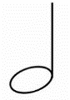
- Let’s Write a Song is a pop song because of it’s structure, studio song and lyrics about love, relationships and having fun – much like ‘It’s all about love’
- This song has two minim beats in each bar
Song for the lesson;
Sunshine On A Rainy Day
Key learning:
- Sunshine On a Rainy Day os a soul song
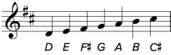
- The time signature again is four crotchet beats in a bar
- The song is in D Major – of which there are two sharps- which means in a higher pitch
Sharps | A sharp means higher in pitch and is shown using #
Crotchet | These are a musical notation which represents the time value of one beat
Minim | These are a musical notation which represents the time value of two beats
Major | Music based on a major scale which can make it sound happy. The simplest major scale can be played on a piano or keyboard using all the white notes, starting and ending on C
Key Words

