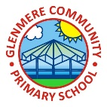 |  | Glenmere Primary School/December 2021 Edition
 | GLENMERE COMMUNITY NEWS
Mrs S Conlon: Headteacher |  |  |  |  |  | Published by Year 6
Punk it up for Pudsey!  There is always a huge excitement and enthusiasm at Glenmere for Children in Need and this year was no exception! This fun filled day took place on the 19th of November 2021. Every class in the school took part in Pudsey day.  As parents entered the gates, there was a colourful Pudsey board where you could pin your loose change on it with blue tack was a game changer and turned out to be an awesome way to make money!  During this day, the children could pay for mouth-watering cakes and a plethora of other activities throughout the school: including a huge cake sale on the playground at break, which raised £150; there was also a raffle for toys, where the children at the school brought toys in to raise more money. Year 5 & 6 held a guess how many sweets are in a jar and year 2 raised £205 by doing bags of activities.  Altogether, we raised £700 and we thought this action from our school was a great contribution as we all worked together and helped each other. We cannot wait to make some more donations to Children in Need! We want to say a huge thankyou to all the parents and carers and legal guardians for letting your wonderful children bring money in. |  |  |  |  | KINDNESS WEEK  Monday the 8th of November was the beginning of kindness week; we started to collect food for the food bank at the King’s Centre in Wigston. We also wrote kind and thoughtful notes on leaves that would be put on a tree. As a Community, we shared our Kindness to each and every one. |  |  |  | The food that had been collected was also sent to people who are disadvantaged and less fortunate than ourselves. We would like to say a big thank you to all parents and carers for letting their children bring spare food/supplies (such as: beans, pizza, advent calendars, soaps/washing up liquid and more): it was incredibly generous
 |  |  |  |  | CHILDREN IN NEED |  |  |  | KINDNESS WEEK
 |  |  |  |  | 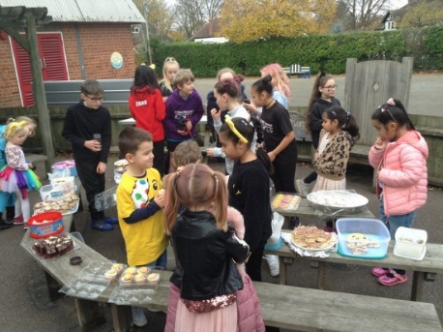  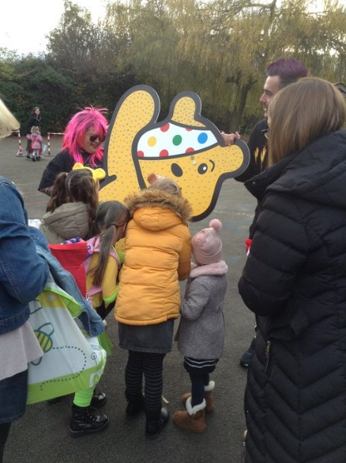 |  |  |  | 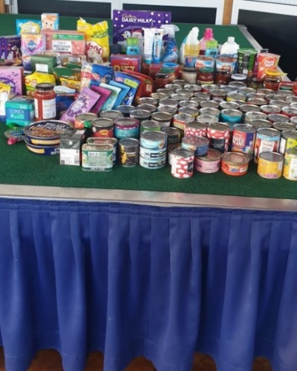  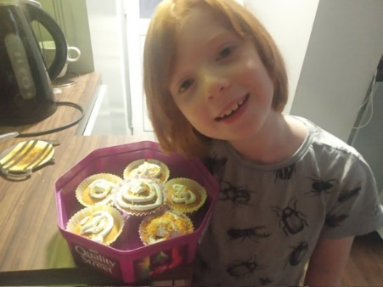

 | GLENMERE COMMUNITY NEWS
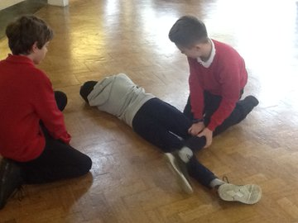  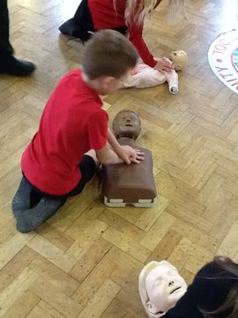 |  |  |  | On the 11th of November 2021, an experienced paramedic (named Steve) taught the children in Year 5 and 6 how to save a life.  At Glenmere Community Primary School, a very nice man/paramedic came into our school (only for year 5/6) and started off with a detailed talk about how long he had been a paramedic for - over 30 years - and what paramedics do (they go to people’s houses and save them). Steve told - and showed - us how to act and what to do if someone lost consciousness. Later, we practiced putting people in the recovery positions and did CPR on dummies.  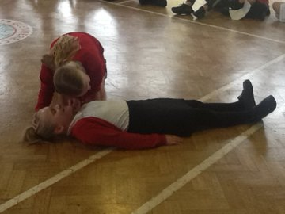 |  |  | After that, we came back into the hall and sat down into a large circle. Steve used some special ingredients -like fake blood, which was made of some sort of soap and then picked out random people to come out and gave them fake injuries. We were then shown how to apply dressing to these injuries and the importance of doing this properly.  Next, was the majority of children’s favourite part: the bandages; everyone was able to select a partner to wrap some bandages around their hand or legs. Some did better than others, but everyone had a go at practicing treating wounds. The children realised how important this was and enjoyed it immensely.  We are very grateful to Steve for taking time out of his busy schedule to come and teach us some basic first aid skills.

Learning how to save a life

Respectful Remembrance  On Thursday 11th November, it was Remembrance Day. To raise money, we sold slap bands, zip poppies and pin poppies for the outstanding charity - Poppy Appeal. At 11 o'clock, we held a 2 minutes silence to respect the people who have fought in wars. Different classes made displays outside their classrooms to remember soldiers, who died in the war, as well as wearing poppies on our school uniform to resemble the poppies on the battle fields. As we waited in our 2 minutes silence, we heard 3 cannons go off coming from the Memorial Park in Wigston. |  |  |  | As it was poppy day, the children did lots of work about the poppies in the battle fields and what poppies represent. We also learnt about when the poppies came and how they represented the blood that was shed on the battlefields and after the war.  All of the children in the school thought it was very important to show our respect and raise money for the people that have fought in wars and helped to keep us safe and let us live the lives that we do today. |  |  |  | 