Class 6 Personal Development
British Values Key Vocabulary
British value  of democracy | democracy, vote, voting, secret ballot, government, one person one vote, laws, rules, parliament, council, representative,  campaign, democratic change, society
British Value  of rule of  law | law, rules, everyone, rights and responsibilities, police, courts, proper order, safety, wellbeing.
British value  of mutual  respect and  tolerance for  diversity | respect, mutual (two way), diversity (gender, disability, faith, belief, ethnicity), care, friendship, everyone has beliefs  and some people have religious beliefs.
British Value  of individual  liberty | choice, own beliefs, freedoms, liberty, individual, each person, protect.
Other experiences that will take place throughout the year to support and promote our Personal Development
Fundraising: Children in Need, Red nose Day, Jeans for Genes, Christmas Jumper Day (save the children), Harvest Festival.
Experiences: Cooking, baking, trips, competitions, visitors, workshops, theatre companies, escape rooms, gardening, life skills
Assemblies: Everyone Welcome, Picture News, Protected characteristics, Values, Awareness Days. Visitors assemblies
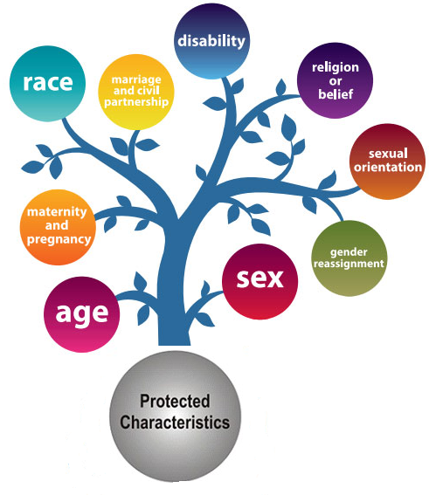

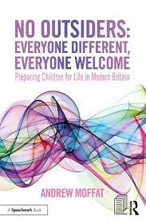
Physical Education
basketball, Tennis, Swimming, athletics, games including dodgeball, tag rugby, quick cricket, hockey, rounders.
Active maths & active English

No Outsiders, Everyone Different, Everyone Welcome
Book | Learning intention
The Island By Armin Greder | To consider causes of racism
Introducing Teddy by Jessica Walton and Dougal MacPherson | To show acceptance
A Day in the Life of Marlon Bundo by Marlon Bundo and Jill Twiss | To consider democracy
Leaf by Sandra Dieckmann | To overcome fears about difference
The Only Way is Badger by Stella J Jones and Carmen Saldana | To consider language and freedom of speech
King of the Sky by Nicola Davies | To consider responses to immigration

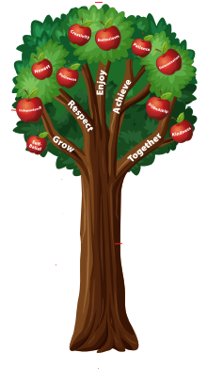

School Values
grow | Self Belief and Independence
respect | Honesty and Politeness
enjoy | Creativity and Enthusiasm
achieve | Patience and Determination
together | Friendship and Kindness

