Science Focus | Sound | Year 4 | Autumn 2
Key Knowledge
What is sound? | A noise that can be heard by someone.
How is sound made? | A sound happens when something vibrates.  This can be obvious:  Like when a drill is hitting the ground repeatedly which causes a loud noise  This can be less obvious:  Here the air in the bottle vibrates to produce the noise
How does sound travel? | Sounds can travel in two ways:  • Through the air - like from a TV speaker across the room to your ears  • Through an object/material - like stone, brick, water and glass. If someone moves furniture upstairs, the sound can travel through the floor to you.
How do we hear vibrations? | • The vibrating air hits our ear drums and makes them vibrate.  • The vibration is picked up by our brains and converted to sounds we recognise.
Volume | • The closer we are to the sound source, the louder the sound will appear to us.  • The further away we are from the sound source, the quieter the sound will appear.  • The more energy in the initial vibration the louder the sound will be. For example, if you tap a hammer on a desk the sound will be quiet, but if you smash a hammer on a desk it would be much louder.
Pitch | The pitch is how high or low a sound is.  • The shorter the vibrating object, the higher the pitch of the sound. • The longer the vibrating object, the lower the pitch of the sound.  With string instruments, the tighter the string, the higher the pitch of the sound.
Key Vocabulary
Vibrated | Move continuously very quickly
Obvious | Clear and easily seen
Material | What something is made of
Recognise | To see or spot something
Initial | Happening at the beginning

Diagrams and Symbols
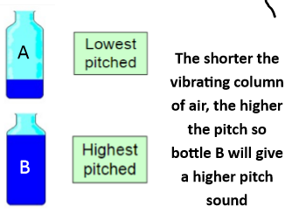

Greater Depth Thinking

Possible Experiences
• Use violins in school to experiment with pitch
• Use one object (such as a saucepan) and try and create a scale of sounds by manipulating it
• Experiment with a tin can telephone

